Welcome To "Government Contracts for Dummies"

Welcome to the '18 Day Govcon for Dummies' training program.

Over the next 18 days I'm going to be sending you a video each day that will walk you through the simple steps you need to follow to land your first contract using the SAM (System for Award Management) portal.

We normally sell this training program for $197 - but you're getting it free because I KNOW that if you implement this training, and do the assignments each day, then in less than 3 weeks from now you'll bet set up to start winning U.S. federal government contracts ... a HUGE win for you.

And if you have an active SAM profile than YOU ARE eligible to start making money, then you'll probably become a Scorecontracts superfan, which is a HUGE win for us!

So, it's a WIN / WIN...

But, only if you take action and do each of the steps.

So, we broke it down and made it SUPER simple. This is how it works.

Each day you will receive an email from me, and inside of that email there will be a video to watch, and one simple 1 task that will only take about 10-12 minutes to implement.

If you get stuck on any step, then our support team will be there to make sure you get it done.

When you follow the 18 day 'Govcon for Dummies' training, you will start with an idea, and end with an awesome sales funnel.

Sound like fun?

Cool, then start today's training below:

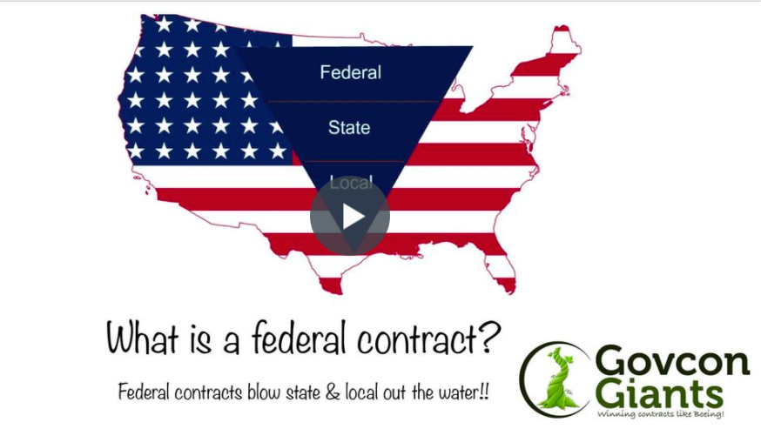

In this first video I’ll walk you though your itinerary over the next 18 days. I’ll explain a little about myself and why believe it is critical knowledge for everyone to know government contracting.

Also, we are going to go over some important tips to help you navigate the next 18 days successfully.

Today’s HW assignment is fairly easy, we want to make sure you receive each day’s lesson so pay close attention.

Go and watch today’s video here and get started!

Govcon for Dummies Eric Coffie Introduction

See you Tomorrow!

Eric Coffie

